**Short Treatments**

**Top 3**

1. train_reward_score[:propensity] : 0.5089521853665767

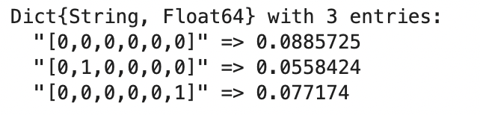

1. test_reward_score[:propensity] : 0.5013239080233148

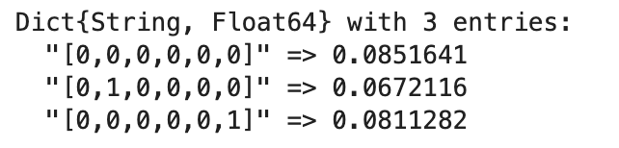

**Top 10**

1. train_reward_score[:propensity] : 0.23646724931033775

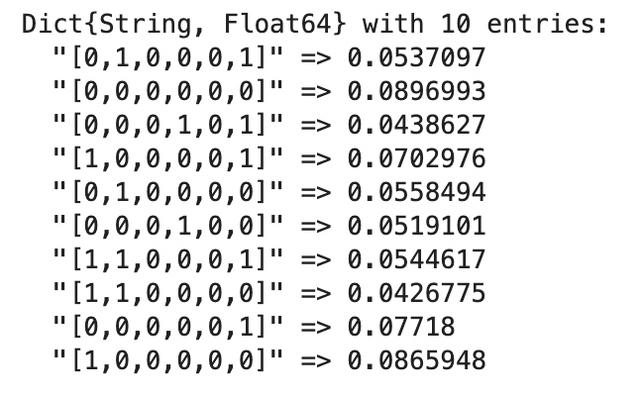

1. test_reward_score[:propensity] : 0.23640397561997198

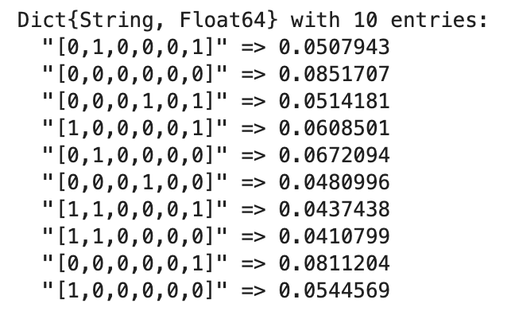

**Long Treatments**

**Top 3**

1. train_reward_score[:propensity]: 0.9092183048818907

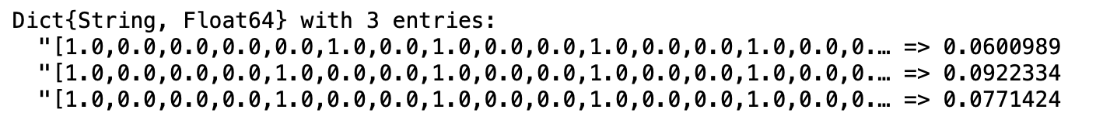

1. test_reward_score[:propensity]: 0.9112702487956824

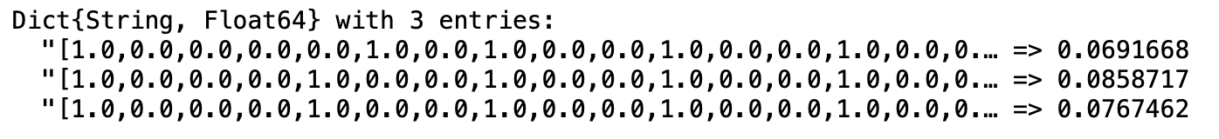

1. Our prescriptions - readmission outcome: 0.427643209515333
2. Current practice - readmission outcome: 0.45038341456172215

**Top 10**

1. train_reward_score[:propensity]: 0.5773648846849607

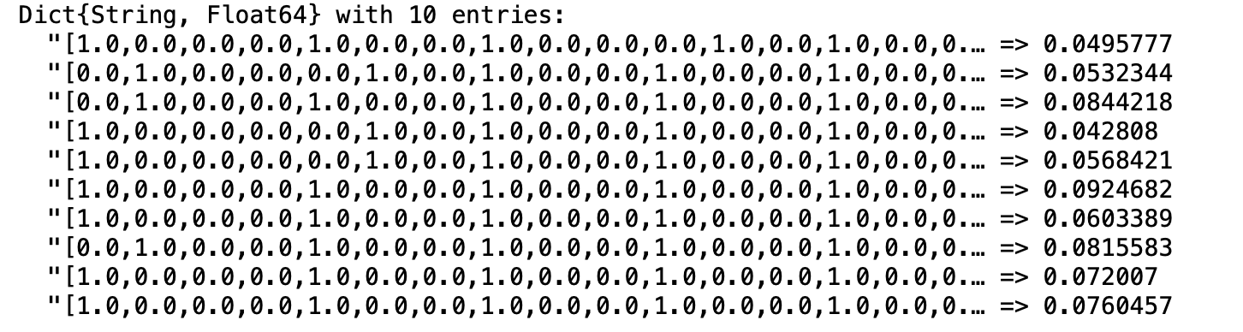

1. test_reward_score[:propensity]: 0.5677485916619679

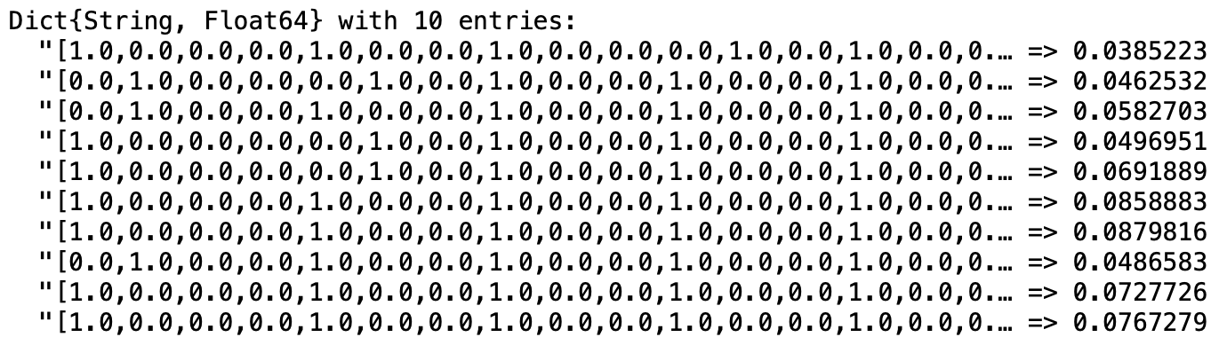

1. Our prescriptions - readmission outcome: 0.42955318962329825
2. Current practice - readmission outcome: 0.4664250615772463